


19 Edition
Welcome to the latest edition of the St Peter’s Green Team Newsletter!!!
We aim to bring you news about what we have been doing, facts and information about climate change, advice on what you can do to help, fun facts and good news stories. We hope you enjoy reading our newsletter and we can help you to think global and act local!
Anti-Litter Campaign
By John-Patrick Maher

At green team this term we have made posters at school to put out next school year to stop littering in our school so that animals and nature don’t suffer and to stop the seagulls. This will help our school look better to visitors, reduce our environmental impact and protect local wildlife. (An example of one of the posters is below)
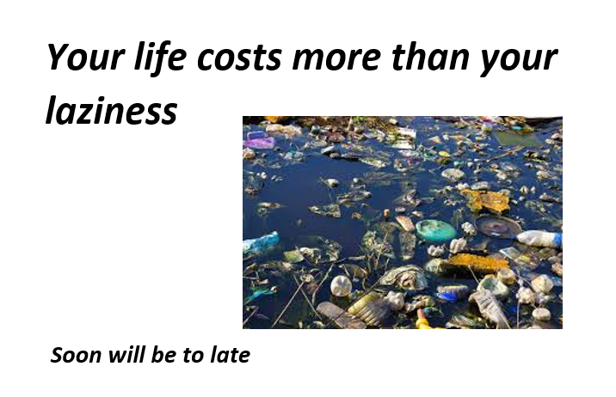
At Green Team we have also made a PowerPoint to highlight the issues of littering like the death of many people because of it and the years it takes off your lifespan. We divided the PowerPoint into 4 sections; littering effects, ignorant littering, death of marine animals and what to do to stop littering. (One of the slides can be seen below.)
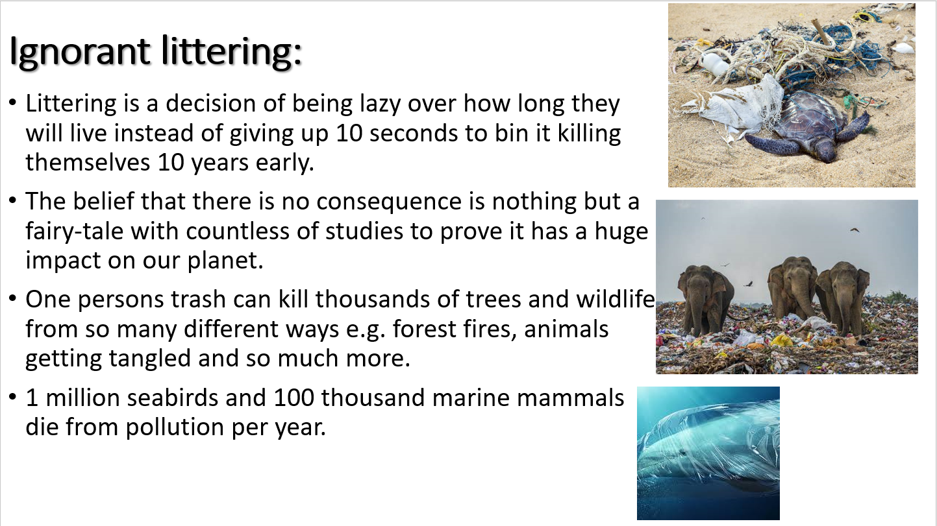
We have taken hours of research into this topic and learnt the many impacts and threats it poses to the earth and the life on it leading us to make the things we have already presented to you.
Look out in September for the PowerPoint and posters and help us to protect the environment.
Good news story!
By John-Patrick Maher
Did you know that over 30% of the world’s energy is now renewable energy and that is a massive difference when compared to 5 years ago. It is estimated all energy will be renewable by 2050 or earlier.


FUN FACT!
By Max Cook

Using AI, scientists designed artificial molecules for gene control in animal cells.
It can also be used for targeted drug delivery. This can be used to target areas such as tumours.

Frightening Fact
By John-Patrick Maher

So many species go extinct every year, scientists don’t even know how many exactly go extinct, causing it to be estimated to how many go extinct and this is in the tens of thousands.
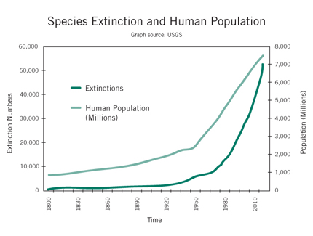
Final words for the end of the school year
By Miss Holliday
The Green Team have gone from strength to strength over this academic year. Our wonderful Year 13 students have helped to lead the group and we gained some great new members. We said a sad farewell to Callum and Ewan (year 13) as they leave St Peters and move on to pastures new and we wish them all the very best in their futures.
Our newsletter is a great success each term with some wonderful feedback which the students love to hear and I thank all of you who take the time to send those messages to us.
As we move to a new school year in September, we would love to welcome some new faces who can join us on our journey to make St Peters a more eco friendly place and help to protect God’s Creation (one of our Catholic Social Teaching principles). If you would like to find out more about Green Team, please feel free to come along and have a chat with me at the Science Prep Room (Room H5 from Sept), or come along to Lab 10 on a Tuesday, 1st break (J1 in Sept).
By attending Green Team, you can earn points towards the ROCK award as well as the much-desired Green Team Badge
A big thank you to JP and Dylan for all their hard work this year and I look forward to everything you will achieve with Green Team next year!

Timmy the Turtle’s Termly Top tips!
By John-Patrick Maher and Max Cook
What you can do to help the environment is try repairing or finding another purpose for your clothes. You can also recycle your old towels, cloths and curtains.
You can also use the heat what is going on in the UK to your advantage right now using it to dry your stuff outside instead of using a tumble dryer.


