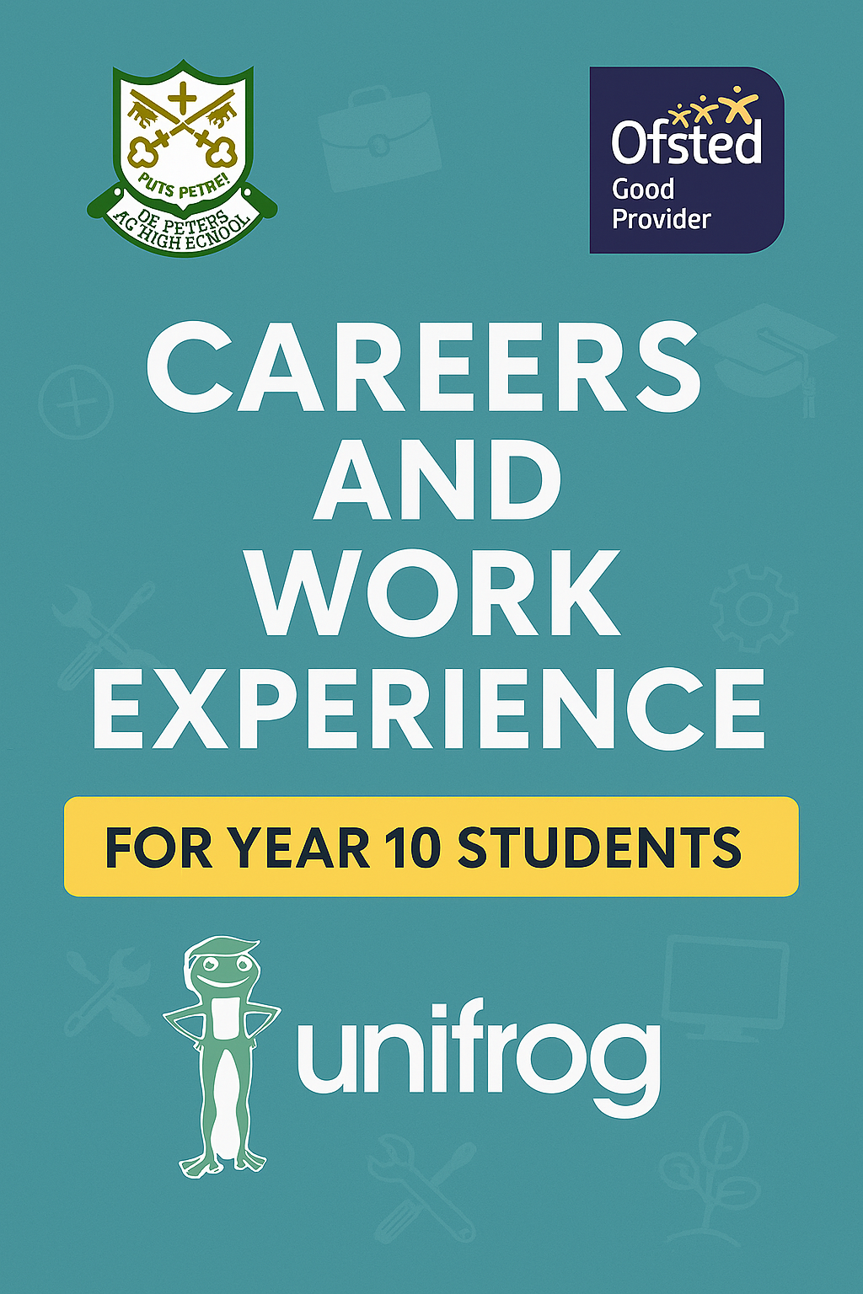

NAME:
FORM:

Why do we offer students the opportunity for work experience?
Work experience helps a student learn about industries they are interested in and gives the student an opportunity to find out if they are suited to that industry or not. Work experience also provides students with examples to write about in future applications and on their CV, and for some sectors (e.g. education, medicine and veterinary science), admissions and recruiting staff will expect to see relevant work experience on your application.
Work experience can also help individuals build professional relationships and expand their network, which can be crucial for career growth and finding future job opportunities.


When do we offer students the opportunity for work experience?
Year 10 – ALL Year 10’s will complete work experience 29th June -3rd July 2026.
If no placement is secured, then school attendance during this week is compulsory.

Knowing where to go for your placement
Do not worry if you are not sure about the kind of career you want. Work experience is a great way of trying out a career to see if it is for you.
Before you start to investigate specific careers, it can be helpful to think about what you like to do and where you feel your strengths lie.

 Ask yourself the following questions:

What are my favourite subjects at school?

What subjects am I good at? | What subjects do I find more difficult?
What do I enjoy doing outside of school? Could I turn my hobby into a career?

 Can you name any jobs that might fit in these sectors?

Construction  …………………………………..  …………………………………..    …………………………………..  …………………………………. | Health & Science  …………………………………..  …………………………………..  ………………………………….  …………………………………. | Hair & Beauty  …………………..………………  …………………..………………    …………………..………………  …………………..………………
Legal, finance & Accounting  …………………………………..    ………………...………………... ………………..………………...  ………………..………………… | Protective services  ………………………………….  …………………..……………..  ………………..………………..  …………………..…………….. | Creative & design  ………………………………….  ………………………………….  ………………………………….  ………………………………….
Social Care  ………………….……………….  ………………….……………….  ………………….……………….  ………………….………………. | Childcare & education  …………………………………..  …………………………………..    …………………………….  …………… | Catering & hospitality  ………………………………….  ………………………………….    ………………………………….  ………………………………….
Environment, land & animal  ………………….………………  ………………………….………    ……………………….…………  ……………………….………… | Business & administration  ………………….………………  ………………….………………    ……………….…………………  ……………….………………… | Cyber & digital  …………………..………………  …………………..………………  …………………..………………  ………………..…………………
Engineering & manufacturing  ……………….………………….  ………………….……………….  ………………….………………. | Sales & marketing  ………………….……………….  ………………….……………….  ………………….……………….  ……………….…………………. | Transport & logistics  ………………..…………………    ………………..…………………  ……………..……………………  ……………..……………………
Sport  …………………………………….  …………………………………….  ……………………………………  …………………………………… | Retail  ………………………………….  ……………….…………………    …………………….……………  ………………….………………

Pick three sectors you think you would like to work in and write down why.

Sector | Why I would like to work in this sector
 | 

Pick three sectors you think you would NOT LIKE to work in and write down why.

Sector | Why I would NOT LIKE to work in this sector
 | 
 | 

Skills employers are looking for
Whatever the job role that you are looking for, you can be confident that the employers will be looking for the most suitable candidates for the specific roles. Businesses need to recruit people who have the right attitude and behaviours.
Can you circle the skills you think are most important to employers?
  Communication |  |   Teamwork
  Problem Solving |  |   Creativity
  Organisation |  |   Self-belief
Leadership |  | 


Rate your confidence 1-5 against these 7 skills (1 = low confidence, 5 = high confidence) and write down one thing you could do to improve these skills
Communication ………………………………………………………………………………..
Teamwork ………………………………………………………………………………..
Problem Solving ………………………………………………………………………………..
Creativity ………………………………………………………………………………..
Organisation ………………………………………………………………………………..
Self-belief ……………………………………………………………………………….. Leadership ………………………………………………………………………………..

How do you find work experience opportunities? 
- Be realistic about where you enquire. Bigger companies may have set programmes for you to apply for on set dates, so keep an eye on their websites/social media pages.
- Ask family, friends, teachers and older students for help, as they may have useful contacts.
- Listen to the Careers updates during tutor time.
- If you are struggling to think of where to go for your placement, the buzz quiz will be able to help you (https://www.careerpilot.org.uk/information/buzz-quiz). This quiz looks at your strengths and areas of interest and then summarises potential careers that may suit you (all of this can be found in the right hand column).
- You can also use the National Careers website: www.skillsforcareers.education.gov.uk


Work experience
contact
list

List companies and contact details in the table below and contact them using the email template or letter on the following page.
If you do not know an email address, then call them. Explain who you are and ask if you can speak to whoever is responsible for work experience. Be prepared to leave your own contact details for them to get back in touch with you.
Name of company | Contact information (Name/number/email) | Reply: Yes/No

Template Letter 1
Your Name
Your Full Postal Address
Date
Contact Name (if known)
Employers Name
Employers Full Address

Dear Sir/Madam, (or their name if known e.g. Mr/Mrs/Miss ….)
I am a Year 10 student from St Peter’s RC High School, Gloucester.
I am writing to enquire whether it would be possible to do a work experience placement with you for 5 days on 29th Jun to 3rd July 2026 please.
I would love to gain some practical experience in (chosen field of Work Experience) as I really enjoy (insert reason). I am hoping this will be a career for me in the future and feel the experience you can provide me with will be valuable.
I have (insert relevant skills to the role). In my spare time, I like to (list relevant hobbies and interests). I’m also a member of (list any groups/clubs/activities).
I am a hard worker, who is (insert your qualities) and would love to have the opportunity to complete my work experience with you. I can be contacted on either my address shown above or on (insert email address and mobile number – add if you have one).
My school has also asked me to find out if you are willing to use UniFrog via a link I will send you.
I look forward to hearing from you
Yours sincerely (if you start your letter with the person’s name)
OR
Yours faithfully (if you start your letter with Dear Sir/Madam)
Sign here
Write full name

Template Letter 2
Your Name
Your Full Postal Address
Date
Contact Name (if known)
Employers Name
Employers Full Address

Dear Sir/Madam (or their name if known e.g. Mr/Mrs/Miss ...)
Request for Work Experience 29th June to 3rd July 2026
Year 10 at St Peter’s RC High School, Gloucester, are involved in 5 days of work experience. I am writing to see if it is possible to carry out my work experience at (insert name of employer), as I am very interested in a career dealing with (note the area of interest).
I am (add your age) years old and my interests include (list your interests). I also enjoy (list some area of interests related to this particular job).
I would love to have the opportunity to undertake my work experience at (insert name of employer) because (insert reasons).
OR
If it is possible for me to undertake my work experience at (insert name of employer), I am available to attend an interview to discuss the details of the placement. I am available any time after 3.30 pm on weekdays or on Saturdays if convenient.
My school has also asked me to find out if you would fill in a link on UniFrog. I would appreciate it if you could confirm this, please.
I look forward to your reply.
Yours sincerely (if you start your letter with the person’s name)
OR
Yours faithfully (if you start your letter with Dear Sir/Madam)
Sign here
Write your full name

Template Email
RE: Work Experience
Dear Sir/Madam (or their name if known e.g. Mr/Mrs/Miss ...)
I am a Year 10 student from St Peter’s RC High School, Gloucester.
I’m writing to enquire whether it would be possible to do a work experience placement with you for 5 days on the 29th June to 3rd July 2026.
I would love to gain practical experience in (chosen field of Work Experience) as I really enjoy (insert reason). I am hoping this will be a career for me in the future and feel the experience you can provide me will be vital and valuable.
In my spare time I like to (list relevant hobbies and interests). I’m also a member of (list any groups/clubs/activities).
I am a hard worker, who has excellent (insert your qualities). I would love to have the opportunity to do my work experience with you so I can develop myself further. I can be contacted on either of my contact details shown below.
My school has also asked me to find out if you were willing to fill in a UniFrog link for a smooth admin process. I would appreciate it if you could confirm this, please.
I look forward to hearing from you.
Yours sincerely (if you start your email with the person’s name)
OR
Yours faithfully (if you start your email with Sir/Madam)
Insert name
Full postal address
Contact number

How to log a placement on Unifrog
We use Unifrog to manage the administration of work experience placements. All students have a Unifrog account. Please see Mrs Beeton or Ms Bhaiyat in the careers office or KS4 if you have any problems logging into your Unifrog account. Logging a placement on Unifrog is a 3 step process:
STEP 1: You need to agree the placement with the employer first. You cannot add the placement to Unifrog before you have had confirmation from the employer that it can go ahead.
STEP 2: Ensure you have all the information you need to complete the online Unifrog form (see form over the page). Ask the employer if you do not know any of the information.
STEP 3: You need to add the placement to your Unifrog account. Access the ‘placements’ tool on the Unifrog home page, click ‘add new placement’ and then complete the form. Scan the QR code below or click the link (https://www.unifrog.org/teacher/know-how/preview/how-to-use-theplacements-tool) for a comprehensive guide on the Unifrog placements tool.

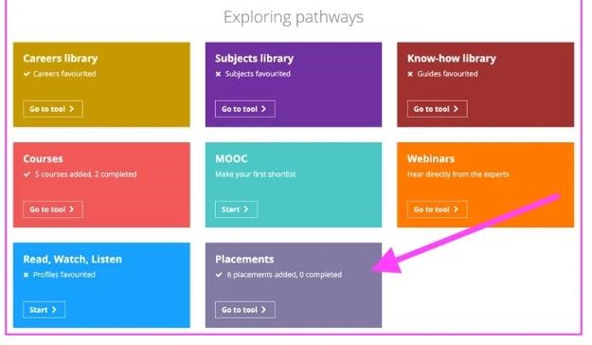


Work Experience Form 

Student Name: ______________________________ Tutor Group: ______
Below is a copy of the Unifrog form that you will need to complete online. Please gather the information needed and then log in to Unifrog to complete the form.

Name of placement business/organisation: _____________________________________
Placement start date: 29-June-2026
Placement end date: 3-July-2026
Placement Coordinator: Mrs Beeton/Ms Bhaiyat
Describe the time commitment: Full-time
Will you meet the employer in-person at any point during the placement? Yes, it’s all or part in-person/No, it’s virtual/remote only
Placement Country: United Kingdom
Placement address: _______________________________________________________
Placement postcode: ______________________________________________
Is this the workplace where you’ll be based throughout the placement: Yes/No
Will you live at home as normal during the placement: Yes/No
How will you travel to and from the placement: ____________________________ What are your objectives for this placement: Write a short paragraph on what you would like to achieve during your placement e.g. experience, confidence, skills etc
Employer placement lead Name: _____________________________________________
Employer placement lead Email: _____________________________________________
Employer placement lead phone number: ______________________________________ Do you have any special needs, illnesses, medical conditions, allergies or injuries that may affect your placement? _____________________________________________________ Parent/Guardian: ____________________________________________________
Parent/Guardian email: _____________________________________________________
Do you agree to abide by confidentiality, safety and absence rules? Tick Agree Tick Finished
Click Add Placement

